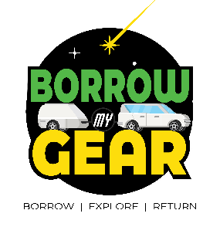
City of Brownville Equipment Rules

1. The City of Brownville has the right to refuse the use of any equipment at any time.
2. A credit card agreement must be filled out during gear pickups unless we have a recent one on file.
3. If equipment is lost, stolen, or damaged, the borrowing individual is responsible for paying to repair or replace the item. (See replacement costs). If the gear is lost, stolen, or damaged due to negligence (2 or more times) the youth leader will lose borrowing privileges for six months. If the damage is due to normal wear and tear the individual will not be held responsible. The decision as to whether an item needs to be repaired or replaced is at the discretion of the individual receiving the returned pack. Invoices will be sent. Unpaid invoices will be charged to the credit card on file after 30 days.
4. Requests for borrowing should be made at least two weeks before a planned trip. It is advisable to make requests as soon as your dates are set in case of conflicts with quantities, pick‐up times, etc. Gear request forms can be emailed to you forms should be requested and sent back to george_garcia@fws.gov
5. Dirty and wet equipment returns will not be tolerated. Please see the return procedures to properly return equipment. The borrowing individual or agency will be charged a fee for each item that is returned unsatisfactorily.
6. Late equipment returns will not be tolerated. If there is a problem with returning gear on time, notify the Operations Coordinator immediately for other arrangements. If the gear is returned late repeatedly (2 or more times) the individual will lose borrowing privileges for six months.
7. The City of Brownville has the right to terminate any individual the ability to rent out the pack if she/he feels the individual is irresponsible with regard to the care and return of equipment. When borrowing equipment from the program, it is expected that you and your group will treat the gear as if it were your own. The following are some general rules to remember when you sign out gear. Thank you for assisting us in the preservation of our equipment.
● Tell us about any issues during your drop-off.
● During your trip isolate or mark items that need attention and label them with repair tags.
● Do not repair issues with duct tape; it can get gummy and hard to remove.
● Do not put any footwear inside the tent.
● Absolutely NO SMOKING inside or around the tent.
● Do not force zippers, this can spread the teeth and ruin the material.
● Stoves: use only butane for backpacking stoves and propane for double burner stoves

